*Xindi Wang and Caitlyn Jelleyman*

*Photon Factory, The University of Auckland*

*Te Kete waiora*

Water Testing Quick Start Guide

# What do I need?

1. Te Kete Waiora
2. A wire and plug to connect Te Kete Waiora to power.
3. 2 cuvettes
4. Nitrate API test kit
5. Plastic vials (at least 2)
6. A 50 mL measuring cylinder
7. Provided standard solution (one small vial per test)
8. Bottle, to collect water samples (at least 150 mL).
9. Sharpie pen
10. A watch, cellphone, clock or timer.
11. A notebook for recording your results.

# How Do I Get a Sample?

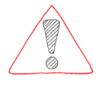To take a water sample, you will need a bottle (at least 150 mL) and a Sharpie pen (for labelling the bottle). Wash the bottle out with some soap and then rinse with water until there is no soap left in the bottle (rinse at least 3 times). Once you have what you need, you can head to your local stream or other water source.

The most important rule about taking water samples is to stay safe:

* Don’t go out of your comfort zone
* Take a friend with you
* Use a stick to hold your bottle so you don’t have to go too deep

If you are sampling from a stream, try to:

1. Take the sample from a place where the water flows and mixes freely.
2. If you can, take samples from a place with a record of water quality measurements so you can compare your measurements against the record.

If you are sampling from a bay, try to:

1. Take three samples: one from the middle and one from each end of the bay
2. Take your sample from a middle depth between the bottom and the surface

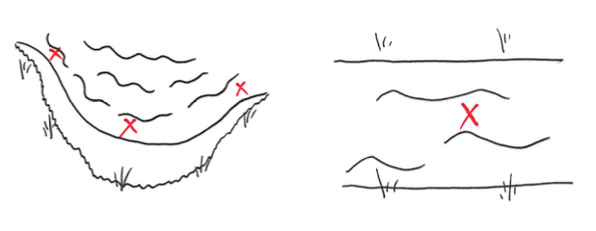

When you’re getting your water sample, rinse the bottle out with the water from the water source first. This will wash out any leftover soap or water from washing the bottle because we don’t want them to interfere with our measurements later on. Then you can fill the bottle with water from the source.

Once you get your water sample you’ll want to label it so you don’t forget where it came from or drink it by accident!

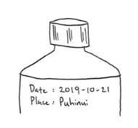

# What to Do?

This is a quick way to estimate the amount of nitrate in a water sample. With a bit of practice, this test will take you about 15 minutes to do.

|  |  |
| --- | --- |
| 1. Turn on Te Kete Waiora at least 10 minutes before use. This gives the LED the chance to “warm-up” fully. | 1. Put 5 mL of the water sample into a clean and empty plastic vial. |
| 1. Shake up API nitrate test bottle #1 and bottle #2 for 15 seconds | 1. To the plastic vial: add 10 drops from API nitrate test bottle #1 then 10 drops from bottle #2 |
| 1. Close the vial’s lid tightly so it doesn’t spill 2. Shake the plastic vial for 30 seconds | 1. Let it rest for at least 5 minutes to give the chemical reaction time to change colour |

While you’re waiting:

|  |  |
| --- | --- |
| 1. Add the standard solution provided with your test kit to the 50 mL flask. Fill the 50 mL flask with the sample until it reaches the line marked on the flask. This is the spiked sample. | 1. Measure 5 mL of the spiked sample into another plastic vial |

1. Repeat steps 3. to 7. for this vial.

Before you measure:

1. Take out your two cuvettes
2. Fill one of your cuvettes using the water sample you are testing. This is your reference cell.
3. Keep the other cuvette for the samples

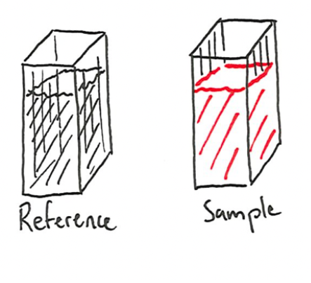

Measuring the absorbance using Te Kete Waiora:

1. Use “UP”/“DOWN” buttons to find the option called “Absorbance” in the main menu. Press “SELECT” to choose this mode.
2. Follow the instructions on screen to finish your measurement. Take care to insert the cuvette with the clear side facing the LED.
3. Record the sample identity and the corresponding absorbance in your notebook.
4. Repeat until you have 5 absorbance values for the water sample and 5 for the spiked sample.
5. Clean any vials, flasks, bottles and cuvettes you used with soap before rinsing the soap out with water (at least 3 times). Keep these for next time.

Example page for your logbook:

|  |
| --- |
| [Date] *31-10-2019* |
| [Sample location] *Puhinui Stream, Totara Park* [Photo] |
| *[Chain of command]: sample taken by Andy at 8:41 am* |
| *stored at room temperature in the car until measured* |
| *by Zara at 9:50 am* |
|  |
|  |
| [Results] |
| *Sample Absorbance* |
| *1 0.020* |
| *2 0.019* |
| *3 0.019* |
| *4 0.021* |
| *5 n/a* spilled the sample when measuring* |
| *Spike Absorbance* |
| *1 0.103* |
| *2 0.108* |
| *3 0.102* |
| *4 n/a* spilled the sample when measuring* |
| *5 0.092* |
| *The concentration of the standard was 210 ppm NO3-* |
| *The concentration of NO3- in the sample was determined to be 2.5 ± 0.2 ppm* |
|  |
|  |

|  |
| --- |
| [Date] |
| [Sample location] |
| *[Chain of command]* |
|  |
|  |
|  |
|  |
| [Results] |
| *Sample Absorbance* |
| *1* |
| *2* |
| *3* |
| *4* |
| *5* |
| *Spike Absorbance* |
| *1* |
| *2* |
| *3* |
| *4* |
| *5* |
| *The concentration of the standard was ppm NO3-* |
| *The concentration of NO3- in the sample was determined to be* |
|  |
|  |

|  |
| --- |
| [Date] |
| [Sample location] |
| *[Chain of command]* |
|  |
|  |
|  |
|  |
| [Results] |
| *Sample Absorbance* |
| *1* |
| *2* |
| *3* |
| *4* |
| *5* |
| *Spike Absorbance* |
| *1* |
| *2* |
| *3* |
| *4* |
| *5* |
| *The concentration of the standard was ppm NO3-* |
| *The concentration of NO3- in the sample was determined to be* |
|  |
|  |

|  |
| --- |
| [Date] |
| [Sample location] |
| *[Chain of command]* |
|  |
|  |
|  |
|  |
| [Results] |
| *Sample Absorbance* |
| *1* |
| *2* |
| *3* |
| *4* |
| *5* |
| *Spike Absorbance* |
| *1* |
| *2* |
| *3* |
| *4* |
| *5* |
| *The concentration of the standard was ppm NO3-* |
| *The concentration of NO3- in the sample was determined to be* |
|  |
|  |

|  |
| --- |
|  |
|  |
|  |
|  |
|  |
|  |
|  |
|  |
|  |
|  |
|  |
|  |
|  |
|  |
|  |
|  |
|  |
|  |
|  |
|  |
|  |

|  |
| --- |
|  |
|  |
|  |
|  |
|  |
|  |
|  |
|  |
|  |
|  |
|  |
|  |
|  |
|  |
|  |
|  |
|  |
|  |
|  |
|  |
|  |

|  |
| --- |
|  |
|  |
|  |
|  |
|  |
|  |
|  |
|  |
|  |
|  |
|  |
|  |
|  |
|  |
|  |
|  |
|  |
|  |
|  |
|  |
|  |

|  |
| --- |
|  |
|  |
|  |
|  |
|  |
|  |
|  |
|  |
|  |
|  |
|  |
|  |
|  |
|  |
|  |
|  |
|  |
|  |
|  |
|  |
|  |

|  |
| --- |
|  |
|  |
|  |
|  |
|  |
|  |
|  |
|  |
|  |
|  |
|  |
|  |
|  |
|  |
|  |
|  |
|  |
|  |
|  |
|  |
|  |

# How it Works

This test relies on colour change to measure the amount of nitrate in a sample. The change is caused by a reaction between chemicals we add from our API test kits and the nitrate in the water sample.

We use a colorimeter to measure the intensity of the colour change. The colourimeter lets us use a number to describe “how red” something is and makes it easier to tell the difference between two samples that look similar.

# Measuring Nitrate:

We spike our water sample by adding a standard solution containing a known amount of nitrate. This makes the solution more red. The difference in redness between the sample and the spiked sample allows us to work out the amount of nitrate in the water sample. We need this comparison because the colour change depends a lot on what else is in the water. For example: in salt water, the colour usually changes less than the same amount of nitrate in fresh water.

# About the Chemicals:

Most tests for nitrate are based on chemicals called “Griess reagents”. The combination of chemicals react with nitrate to change colour. The more nitrate there is, the more red the chemicals in the water become.

The reaction works by first changing the nitrate (NO3-) to nitrite (NO2-). Then the nitrite reacts to make an intermediate.



The intermediate reacts with the yellow N-(1-**N**aphthyl)**e**thylene**d**iamine (NED), to make a red chemical. This causes the colour change that tells us that there is nitrate in the water.



More nitrate means that more molecules of NED can react. This results in the water sample becoming more red with more nitrate.

Thanks to the following organisations for making this possible





